2023-2024 Awana Special Nights & Activities

AWANA Wiener Roast. - Friday - October 13th
Cool evenings, the sight and sound of a warm fire, & family games-the Awana Wiener Roast has something for everyone. Hot dogs & Chips will be provided. Bring a lawn chair and a side dish and/or dessert to share.

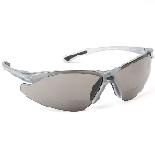
Theme Nights

September 20th—Wear Your Sunglasses At Night Night: Wild & crazy, cool, trendy,
prescription or just plain silly; find and wear some sunglasses and enjoy an enlightening Bible lesson.

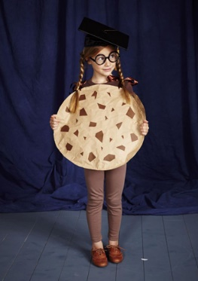
October 25th—Now That’s a Punny Costume Night: Be creative and come dressed
as a visual pun. A smart cookie and smartie pants are brilliant examples.
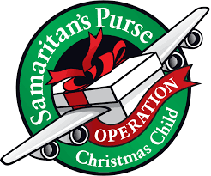
November 8th— Operation Christmas Child Night: Donate an entire box or
just a needed item from our list.

November 15th—Let Us Be Thankful Night
The whole family is invited to a special Thanksgiving style meal.

December 6th—Silent Night
Clubbers will be challenged to remain silent for the entire evening. The quietest club will receive a prize.

January 24th—Farmer’s Feast with all the Fixins Night
After a hard day at work, farmers need a good meal to keep up their strength. Bring the family and join us for a farm fresh meal and a Farm themed Bible lesson.

February 21st— Run the Race Night
Bring your fastest hot wheels car to race on our track and hear a fast-paced Bible lesson.

March 13th —County Fair Night
Who doesn’t love the fair. Experience some Blue-Ribbon worthy food and a Bible lesson for the whole family.

April 10th – Desert Night
Don’t get too excited, there is only 1 “s” in this theme night. We’re talking barren, dry, and dusty not smooth, sweet and chocolatey. Dress for the desert. You don’t need a fork, you need a camel.

Awards Night—May 1st Come celebrate a great year of Awana as we recognize the achievements of our Awana club kids.
Martinsville Bible Church
Expectations & Reminders

Coming and Going
- Please arrive just a couple of minutes before 6:00 pm.
Please enter at the Side entrance under the overhang.
Cubbies and Sparks should be signed in and out from their classrooms by a parent/guardian.

- Please be prepared to pick up clubbers by 7:30 pm. We may occasionally dismiss them a minute or two late. Please be patient and parents are welcome to wait in the fellowship hall at 7:20 and watch the closing before they pick up their children from their rooms.

- Watch for cars – BE SAFE

What to Bring/Wear
- Wear your uniform if you have one (watch for theme nights).

- Wear Tennis Shoes to club for game time. We may not allow clubbers to participate in certain activities if they are not wearing Tennis Shoes for safety reasons.

- Bring your Bible and handbook every week.

- We ask all who are able to bring 50₡ each week for dues.

For Everyone’s Safety
- If you are sick and/or did not attend school, you can’t come to Awana.

- If you think there is a good chance you could be contagious and make someone ill, please stay home.

- We will not have Awana Club if school has been canceled.

Respect
- Use appropriate language; Treat others with kindness; Have respect for personal property.

- Please help keep the building and grounds nice and clean.

Discipline
- Group Setting - we use the “5 Count” to get your attention –you must be quiet by 5!

- Individuals - we use the “3 Count” for clubbers who misbehave.

  - Count One: A specific verbal warning that tells the clubber that their behavior is inappropriate and that they must comply with Awana Club expectations.
  - Count Two: The clubber will be reminded of Awana Club expectations by the club director or the commander.
  - Count Three: The clubber will be removed from the current activity and a meeting will be scheduled with the clubber’s parents/guardians.

